Project Plan

Animal Adoption Center

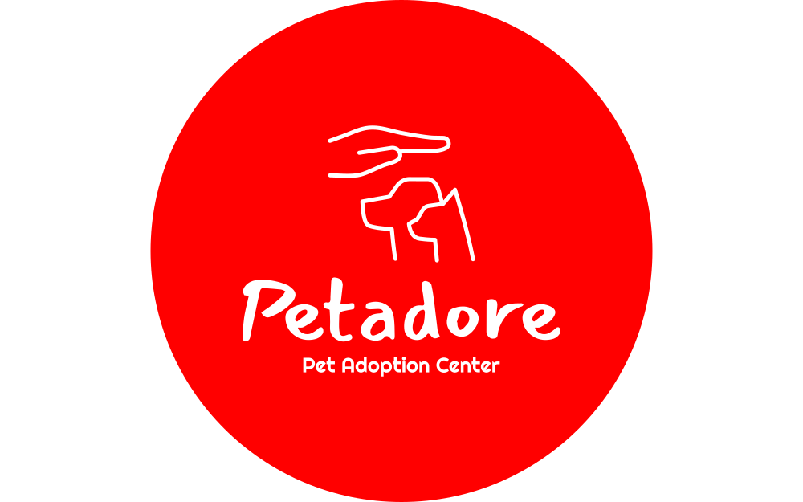

~ Ziyadatan Imad Aqil Mardi

Date: 01-03-2023

Last Updated: 09-06-2023

Table of Contents

1. Introduction 3

1.1 Current Situation 3

2. Problem 3

2.1 Problem Statement 3

2.2 Project Goal 3

3. Solution 3

3.1 Scope 3

3.2 Deliverables 4

3.3 Non-Deliverables 4

3.4 Constraints 4

3.4.1 Project and Time Constraint 4

3.4.2 Development Platform Constraint 4

4. Summary 4

# Introduction

## 1.1 Current Situation

Petadore is a pet adoption center. It uses manual data storage by paper and does not have an online website. They needed to modernize in order for people who wanted to adopt pets to have an easier access to petadore’s collection of animals.

# Problem

## 2.1 Problem Statement

Petadore still uses manual data storage by paper to store the adopted pets and their new animals that has been moved to their shelters. This would usually ends up in mistakes that some animals that has been adopted to be thought that they are still in the adoption center. Some data can also be confused with other animals since each animals have their own traits, they could mistaken one trait for the other animal.

The company also think that having an online website for the customers to see the all the animals the shelter has to offer and can also adopt them online and for them to deliver the animal or pick up the animal later.

## 2.2 Project Goal

The goal of the project is to solve the problems of the data storage for the animals by creating an app to manage these information. The application will also manage the adoption requests made by the customer in order for easier data access. And also to make a website for the customers to see the available and animals and to adopt them online.

# Solution

## 3.1 Scope

The scope is to create a functioning data storage application and a working website. By the start of the 1st and 2nd week, the ideation for the project will be created. By 3rd week, the Project plan and URS needs to be made. On the 4th and 5th week the implementation of the desktop and web application will start.

By 8th week, it is expected for the application to have most of the basic functions for both the web application and the desktop application. Starting from the 9th week, the application should have all of the basic functions implemented and have the pagination and the authorization on the web application to be working and expected to be done on the 13th week. After that, it will be finishing the whole application by adding features, promised to the client and updating the documentation to better fit the new look of the whole application. Both the website and the desktop app.

## Deliverables

|  |  |
| --- | --- |
| **Delivery Date** | **What to deliver** |
| Week 3 | Ideation documentation, Original Project plan, and URS of the application |
| Week 7 | Test Case Documentation and the application with some basic functionalities |
| Week 9 | Application with fully implemented CRUD features, both the website and desktop |
| Week 12 | Add pagination on the website and implement SOLID principles, Customer must be able to adopt the animal |
| Week 14 | Apply some Non-Trivial Algorithm in the application |
| Week 16 | Deliver Final Version |

## Non-Deliverables

* Application will not be available as a mobile app
* Application will only manage the data for the animals and the adopters. Application will not manage the employees of the company

## Constraints

### 3.4.1 Project and Time Constraint

Other than this project, we are also need to work on the group project. Without proper time management and prioritization the planning of the project could go into chaos. Furthermore, the final deadline for the application is on the 9th of June 2023. 1 week earlier than the group project, which means we have less time to work with

### 3.4.2 Development Platform Constraint

* The project will be developed using Microsoft Visual studio
* The programming language used is C#
* The Framework used is .Net 6.0
* For hosting and file-sharing, the development team will make use of GitLab provided by Fontys University of Applied Science
* MySQL will be used for database implementation on the Hera server.

# Summary

In summary, the whole application needs to work as a pet adoption website and manager, to manage and make the whole experience of adopting an animal easier for the customer. The full application with all the functionalities that are able to be added in the application will be fully delivered by 9th of June 2023 before 16:00 CET.